**inSight 2017**

**Department** **: Hostel Office**

**Problem Title** **: Hostel room allocation**

**Problem Code** **: PS02**

**Problem Description :**

With the large number of hostel applications received every year, the allocation of rooms to each applicant is a very tedious task. A software solution which would enable the hostel department with the allocation of rooms which would also make it easy for the students (they don’t have to stand in long queues anymore for allocation) would benefit both the management and the students. The priority number concept must be followed. Priority number is given on the basis of first come first serve basis on the mode of payment.

This system must be able to generate report of occupants of each hostel and the rooms which are unallocated after allocation.

Note: The solutions can include webapps, stand-alone windows systems, android apps etc.

**Proposed solution:**

*We are going to develop an android application that could ease the procedure of hostel room allotment based on priority numbers.*

*This application provides two types of logins:*

*1.Administrator Login.*

*2.Student Login*

***Administrator Login:***

* *Administrator will be provided with a user name and a password ,through which he can query the database and generate the required reports.*
* *Before the allotment procedure he is supposed to enter the student details like USN, Name, Priority number for particular student. And he can also specify a separate list for single occupancy rooms and double occupancy with separate list of priorities.*
* *After the allotment admin can get the complete allotment list and a list of un-allotted rooms as well.*

***Student login***

*Each student will be given with a username and a password through which one can*

*login.*

*During the option entry period specified by the management ,one should login and enter their choices[Room no.s] .*

*Student can get access to following three portals :*

*1.Priority portal*

*2.Option entry portal*

*3.Allotment result portal.*

* ***Priority portal***

*Student will be able to see his/her priority in this portal.*

* ***Option entry portal***

*In the given span of time students are supposed to enter room numbers of their choice in this portal.*

*Where one will do the following operations:*

*Enter the room number choices.*

*He/she prefer an unoccupied room or singly occupied.*

***Note:*** *Even he/she can visualize the map of hostels.*

* ***Allotment result portal.***

*This portal enables the student to see which room he/she has been allotted to.*

***Note:****One can also see details of the roommate like Phone number Name USN.*

**Technology Stack :**

*We will be using :*

*Android studio.*

*SQL ITE*

**Use Case:**

*Two separate database will be maintained for single sharing and double sharing rooms.*

*Each time a priority number will be selected, rooms that are opted are checked if they are allotted or not .*

*If the room is already allotted next choice will be considered and the allotment will be done. If no rooms are allotted of his/her choice then the student will be held back .Which will be considered after allotment of the rest.*

*After completing the allotment process the list will be stored on to database.*

*Admin can be able to get reports of allotted and un-allotted room.*

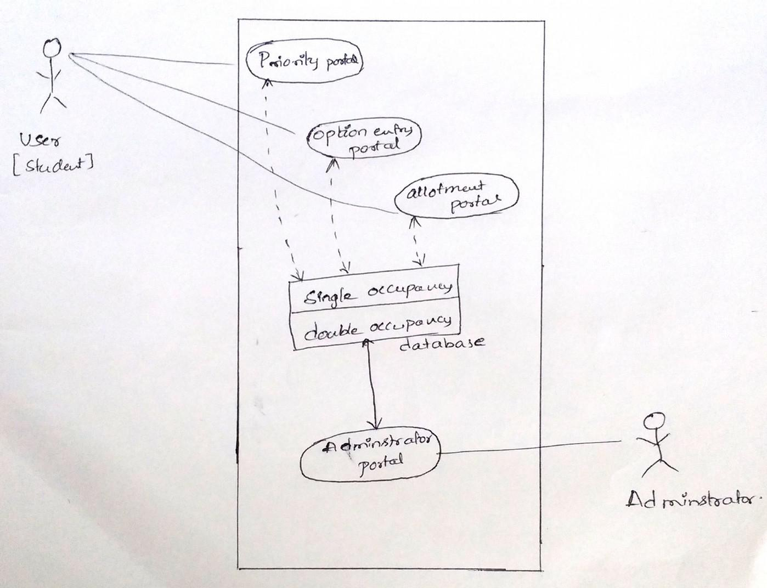

**Team Members details:**

|  |  |  |  |  |
| --- | --- | --- | --- | --- |
| **Role** | **Name** | **USN** | **Email id** | **Phone no.** |
| Team Leader | Rakshitha R | 1SI15CS086 | rakshita.ravi97@gmail.com | 8904547901 |
| Team Member 1 | Purushotham G K | 1SI15CS082 | p[urushotham.gkpl@gmail.com](mailto:Purushotham.gkpl@gmail.com) | 9590984828 |
| Team Member 2 | Bhuvan S | 1SI15CS139 | bhuvan.reddy98@gmail.com | 7795501929 |